Week3

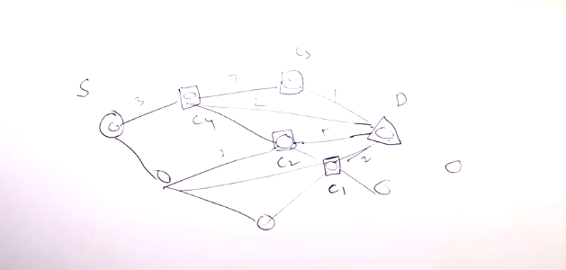

Min (C1+2,C2+5,C3+1,C4+2) recursive find the minimum